AGC STATEMENT, DECEASED AND STAMP DUTY CHARGES COLLECTION

**Exercise 1 (a): Collection of charges statement**

Select the menu **“AGC” Add General Charges**

1. On event ID, use the searcher- Select statement charges you would wish to collect the charges for;-

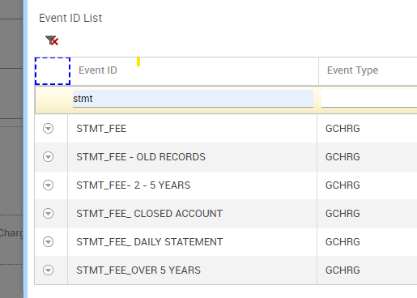

1. Enter the Debit account ID
2. Select transaction type as > transfer Bank Induced
3. Select the appropriate currency e.g KES and the value date
4. Click **On GO** to view the charges collection summary, charges collection will appear on (Calculation Amt. in Charge Debit CCY)
5. Click SUBMIT
6. Use menu IAL to confirm the transaction has been effected and the account debited as expected. Correct account will be debited and the subsequent charge deposited in the correct internal account.

**Exercise 1 (b): deceased charges collection**

Select the menu **“AGC” Add General Charges**

1. On event ID, use the searcher- Select deceased search as below,

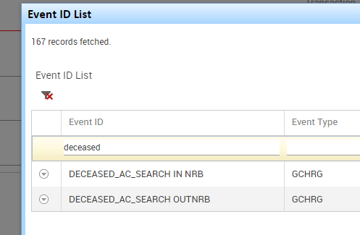

1. Enter the Debit account ID
2. Select transaction type as > transfer Bank Induced
3. Select the appropriate currency e.g KES and the value date
4. Click **On GO** to view the charges collection summary, charges collection will appear on (Calculation Amt. in Charge Debit CCY)
5. Click SUBMIT
6. Use menu IAL to confirm the transaction has been effected and the account debited as expected. Correct account will be debited and the subsequent charge deposited in the correct internal account.

**Exercise 1 (c): Stamp duty charges collection**

Select the menu **“AGC” Add General Charges**

1. On event ID, use the searcher- Select stamp duty search as below,

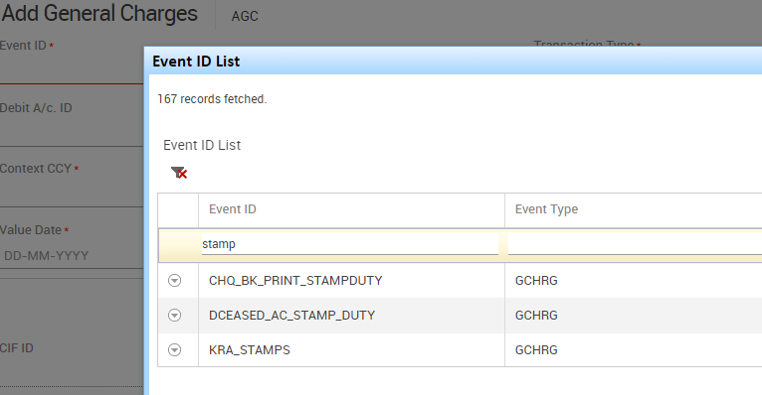

1. Enter the Debit account ID
2. Select transaction type as > transfer Bank Induced
3. Select the appropriate currency e.g KES and the value date
4. Click **On GO** to view the charges collection summary, charges collection will appear on (Calculation Amt. in Charge Debit CCY)
5. Click SUBMIT
6. Use menu IAL to confirm the transaction has been effected and the account debited as expected. Correct account will be debited and the subsequent charge deposited in the correct internal account.